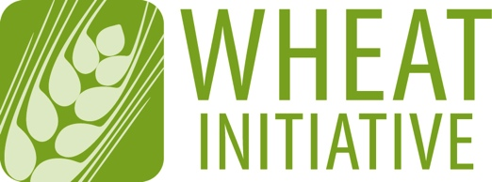
Coordinating global research for wheat

ANNEX 2 (April 2016 update)
EXPERT WORKING GROUP MEMBERSHIP APPLICATION FORM
Please return your completed form to wheat.initiative@julius-kuehn.de (maximum 4 pages)

NAME OF EXPERT WORKING GROUP
Nutrient use efficiency in wheat EWG

EXPECTATIONS FOR EWG MEMBERS
- Participate in EWG meetings and ongoing discussions
- Contribute to the activities of the EWG
- Expertise in the following topics
- Nutrient use efficiency (NUE) in small grain cereals and particularly wheat
- Physiology of nutrient uptake, partitioning and remobilisation of nutrients, particularly but not restricted to nitrogen
- Germplasm screening and breeding for NUE
- Genetics underpinning NUE
- Genetic solutions for enhancing NUE
- Roles of both root function/architecture and canopy performance into contributing to NUE

1 - CANDIDATE DETAILS
First Name
Last Name
Wheat Initiative
Website Username*
Position
Country
Institution/Company
Email
* If you do not have a website username, please create your personal account on the Wheat Initiative website (www.wheatinitiative.org). It is recommended that you take your username as First Last (e.g. John Smith). Your username will be needed to access a private online workspace for EWG members.

2 - PROFESSIONAL ACTIVITIES
Research Activities
Other Activities

3 - PUBLICATIONS RELEVANT TO THE EWG TOPIC

4 - OTHER TYPES OF PRODUCTIONS

5 - ADDITIONAL INFORMATION (in particular, reasons why you would like to be a member of the EWG and what specific expertise or relevant experience you could contribute to its development)

